**Final Assignment and OTher assignments are uploaded to git. Get url from below .txt file**



**Assignment ZIP Attachment**





**Application Logs - **

**Extract the above src folder above and run using the following commands.**

**BACKEND -CODE:**

* **I have made this project in spring boot to make it portable and easier to configure**
* **You can run this in two ways -**
* **Go to project folder**
* **Open the mvnw.cmd file and set java Home path**
* **Example for my system -** set JAVA_HOME=C:\Program Files (x86)\Java\jdk1.8.0_92
* **Open Command Prompt in the project folder home location and run -** 
  + **mvnw eclipse:eclipse**
* **[WAY 1 To run the application - Using Eclipse]**
  + **Import as general project in Eclipse and the main method in com.cts.fsd.tasktracker.TasktrackerApplication**
* **[WAY 2 To run the application - Using Cmd Prompt]**
  + **Open the command prompt in the project folder home location and run**
    - **mvnw clean install**
  + **Type in the command prompt that is opened in the project folder home** 
    - **java -jar target\tasktracker-backend-0.0.1-SNAPSHOT.war**
* **Use POSTMAN TO TEST THE RESTFUL API METHODS - Use the following postman configuration json to set the post man api method calls in POST MAN. (All Configuration Related work is done for postman. You will need only to modify the method body for calling the POST, PUT and DELETE Methods at run time as you please)**



**Payload for all the API Methods are given in the above .json configuration file. Just import into POSTMAN and see the payload.**

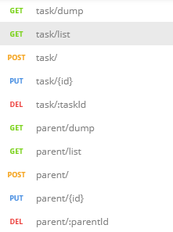**POSTMAN METHODS THAT SHOULD BE PRESET**

* **To Run the WAR FIle using Standalone Tomcat - http://localhost:8080/FSDSpringProject-0.0/**
* **To Run the WAR File generated using embedded tomcat use the steps mentioned above in the highlighted text**

**UI -CODE STEPS:**

**ENTER the UI Folder and run ng serve**

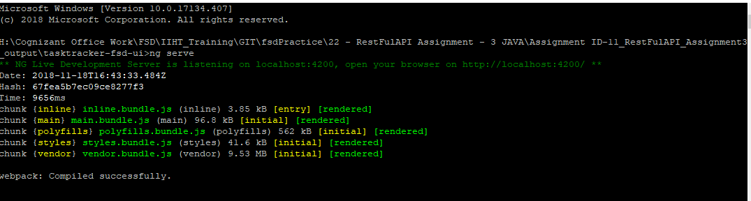

**Now go to browser and hit the url -   
http://localhost:4200/** **Frontend -UI - Screenshots -**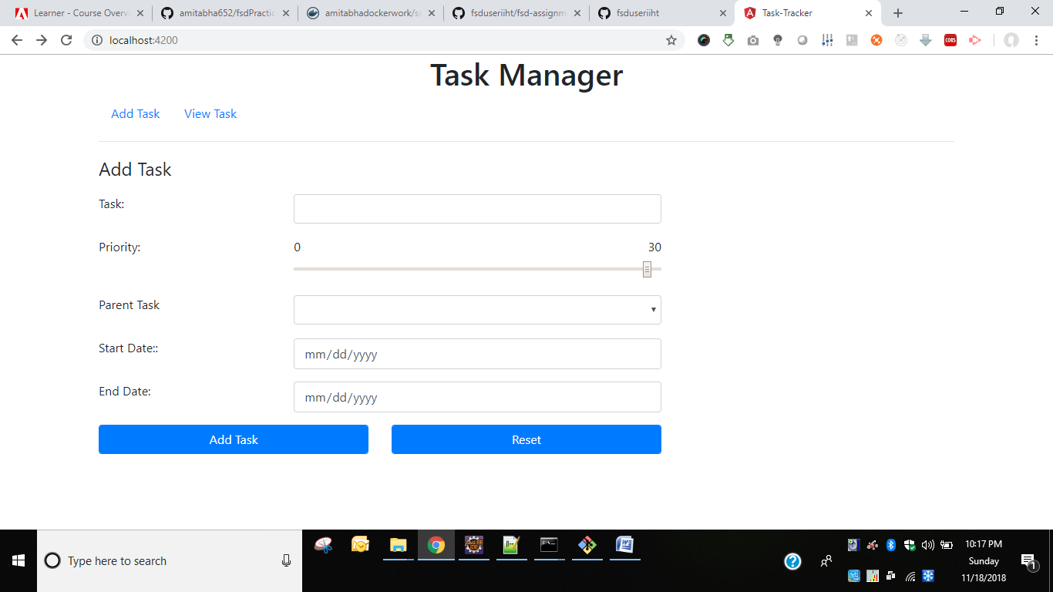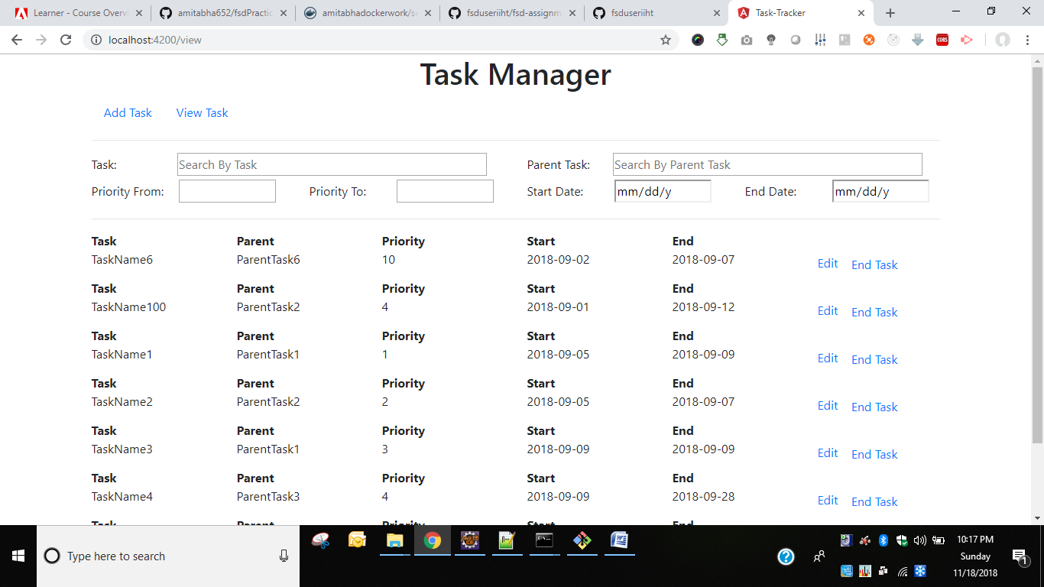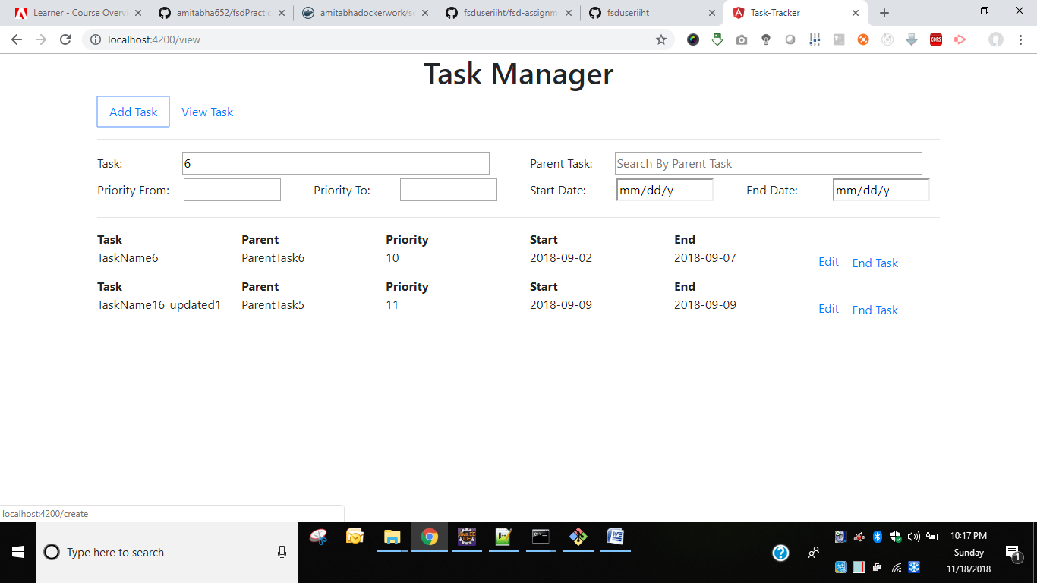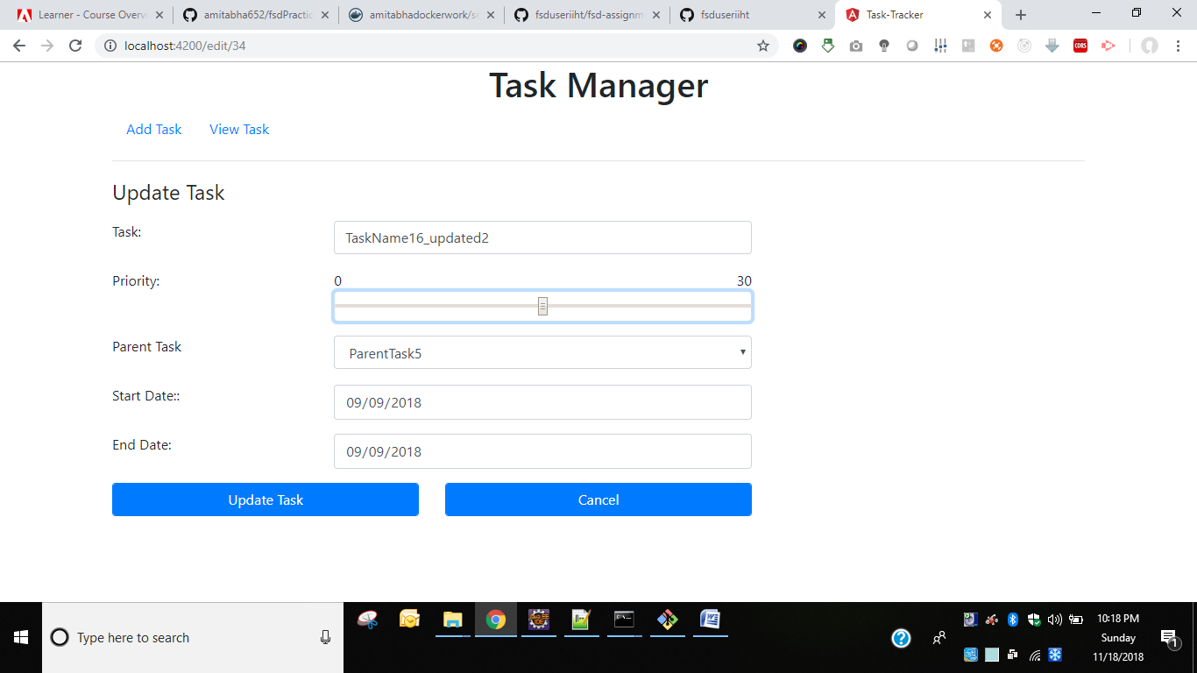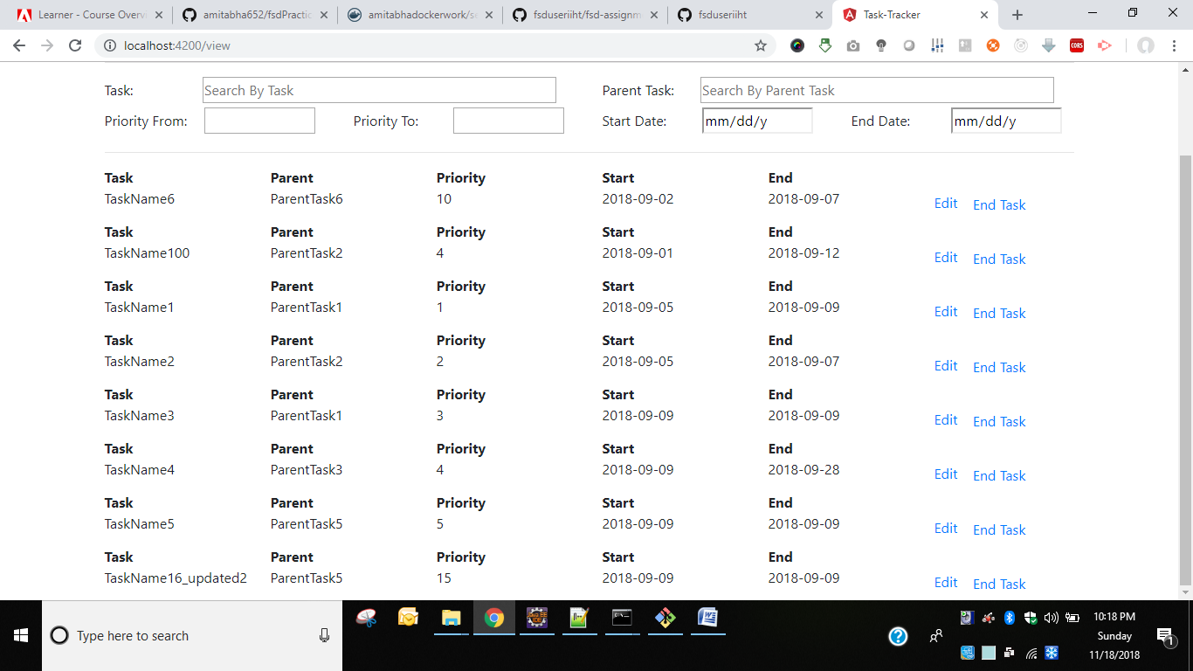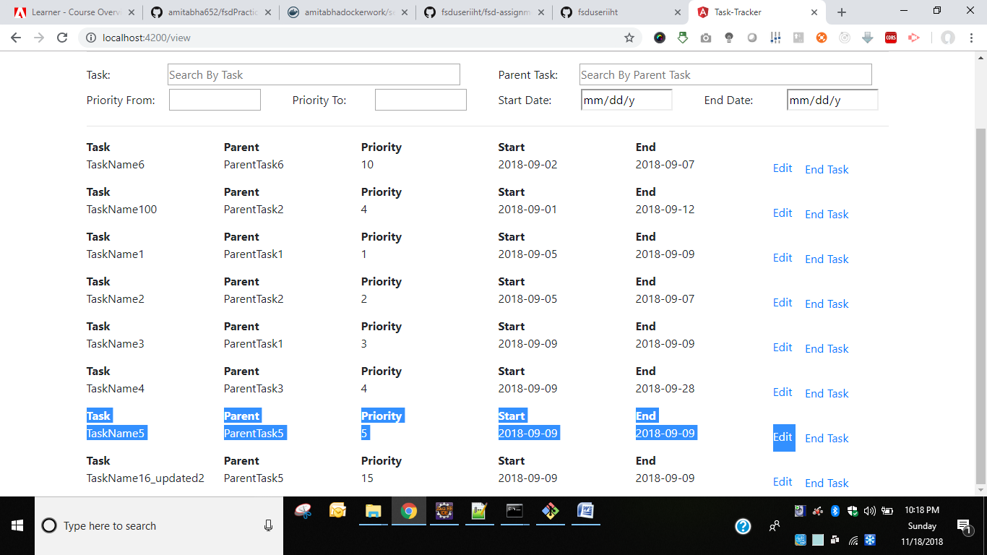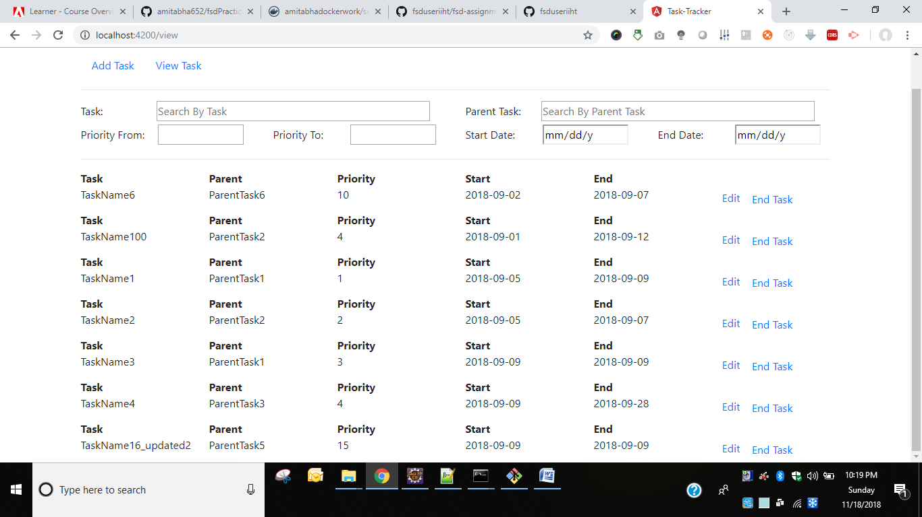

**Backend Output Screenshots -**

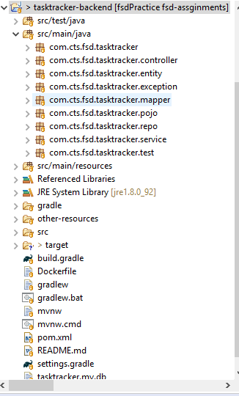

**POSITIVE SCENARIOS INCLUDED BELOW**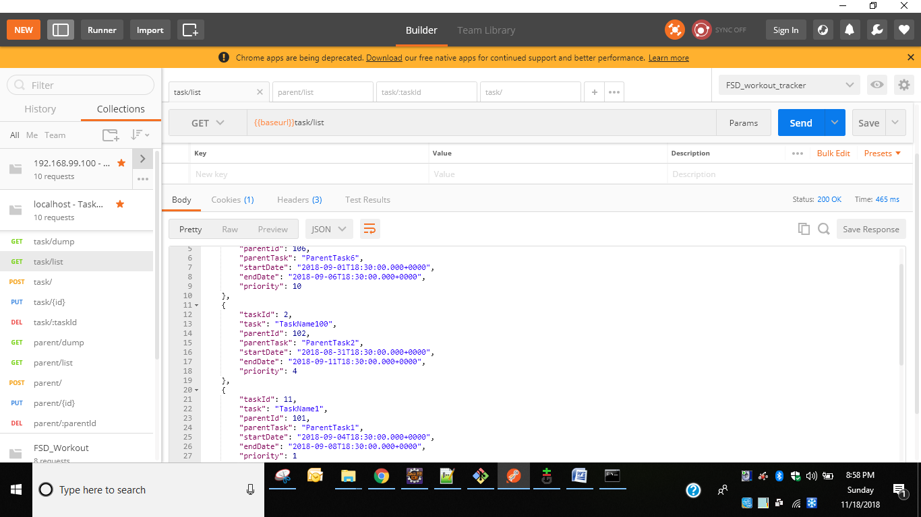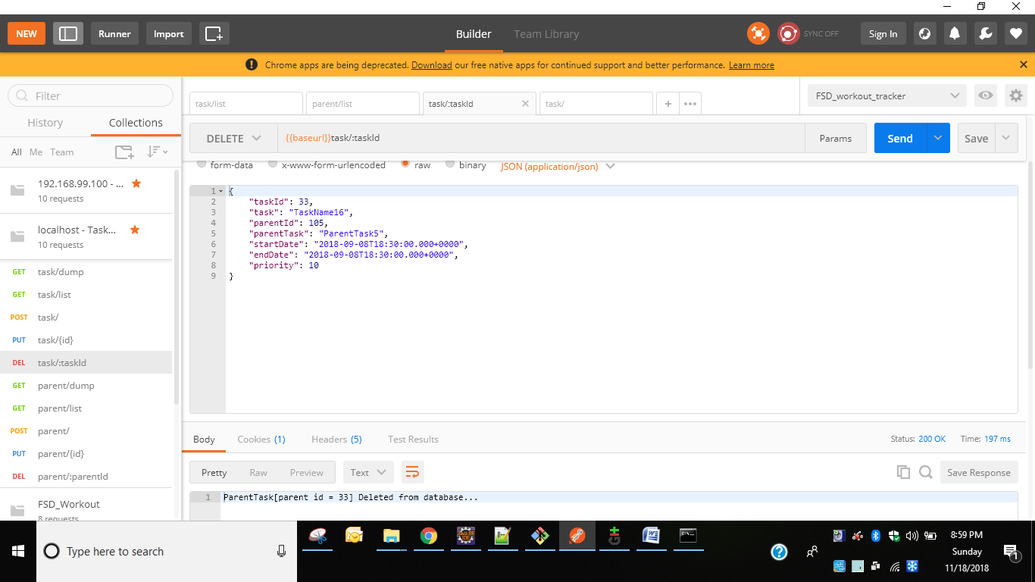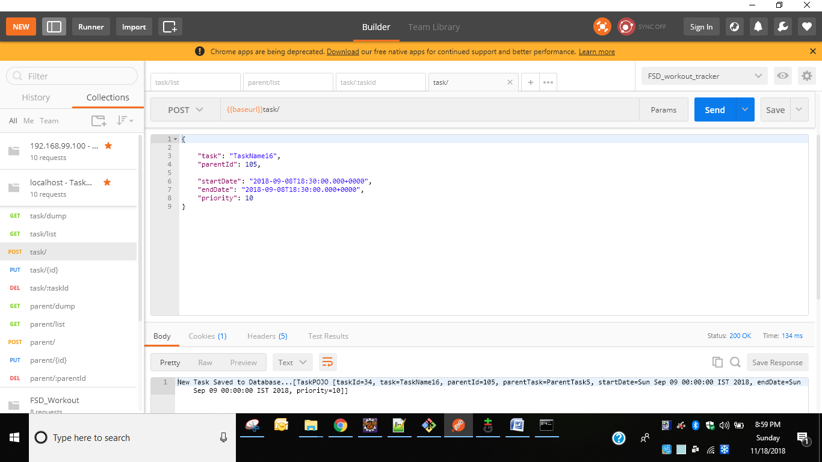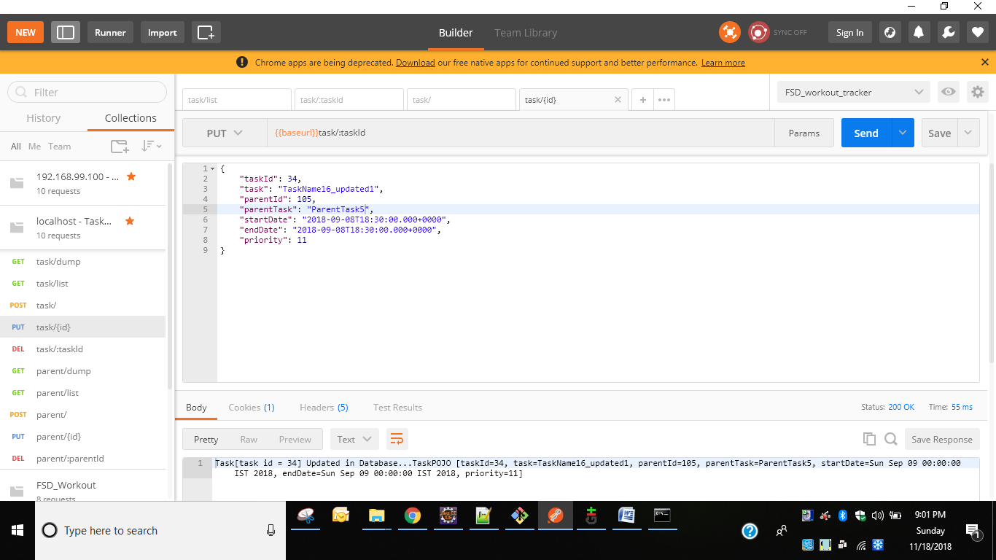

**FOR NULL ID POST -**

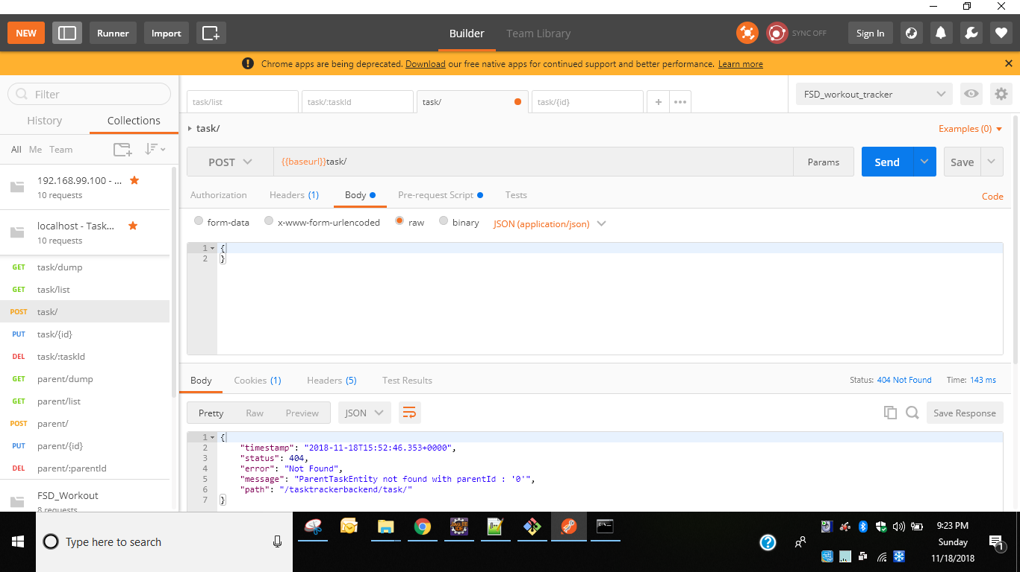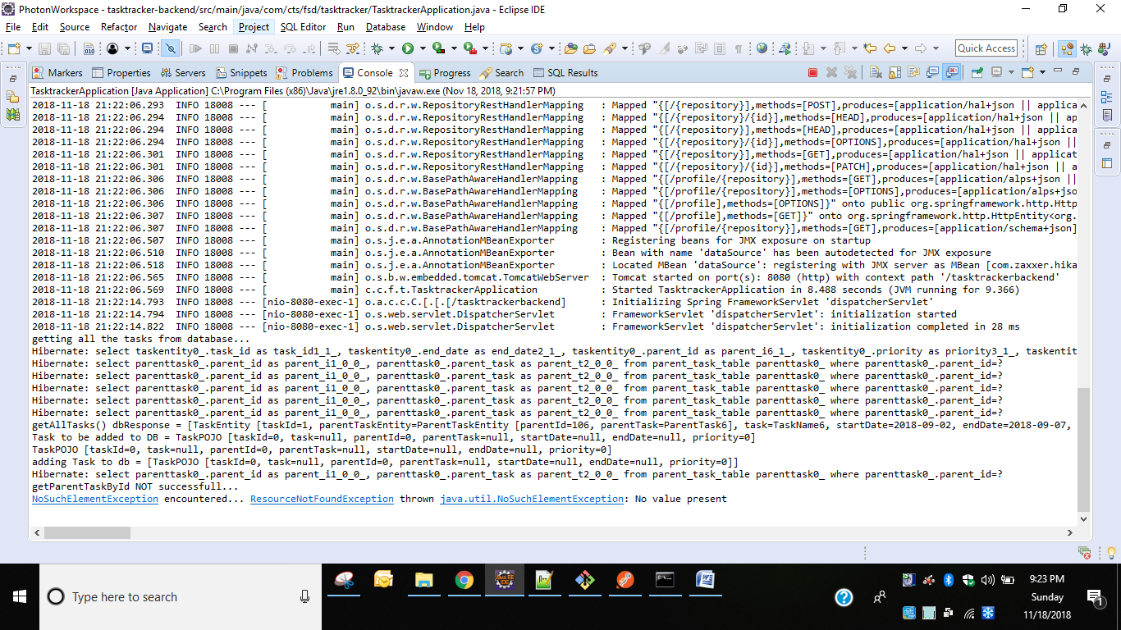

**FOR DELETING NON_EXISTING ID FROM DB-**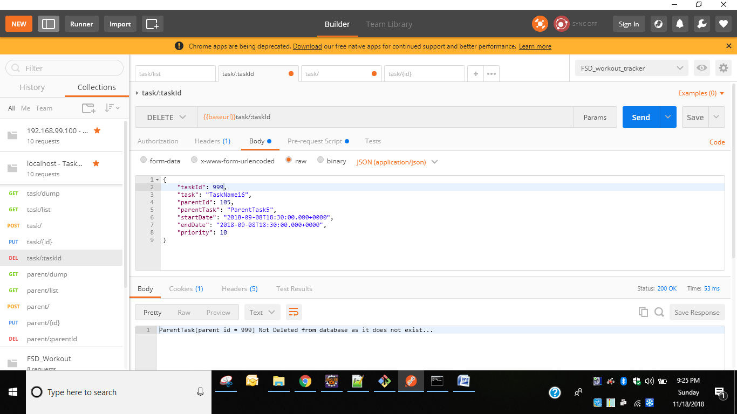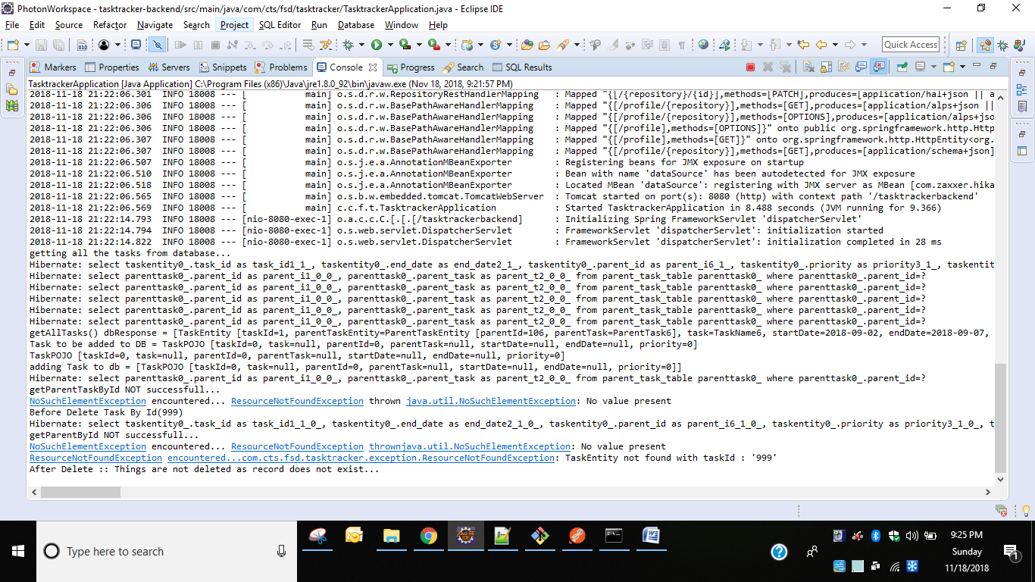

**UPDATING A NON-EXISTING ID IN DB**